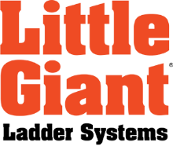

Background
Little Giant Ladders was started in the 1970s in Springville, Utah. What started as a company making one type of ladder has grown to be an International company that makes all types of ladders including extension ladders, stepladders and platform ladders. Little Giant’s competitors include other ladder companies, including Tri-Cam, Werner and Louisville. Little Giant Ladders has products manufactured in the United States, China and Vietnam.

Beginning in 2012, Little Giant Ladders recognized an issue in the ladder industry. People use ladders unsafely, leading to catastrophic injuries and even death. In fact, someone dies from a ladder-related accident every single day. To combat this issue, Little Giant developed a PR campaign focused on bringing awareness of ladder safety and sharing information on how to prevent ladder-related injuries. For the purpose of this campaign presentation, this ladder safety campaign will be the PR plan for one year.

Research:
Primary Research
Salespeople and others who worked at the tradeshows gathered qualitative data from customers and safety officers about safety and their familiarity with Little Giant’s approach to safety. The marketing team also conducted focus groups to gather more qualitative feedback on the company’s approach to preventing ladder-related accidents.

A way to improve the primary research would have been to gather some quantitative data to gauge people’s perceptions of the company. Another way to improve the primary research would have been to have set questions to ask people at the tradeshows, since the current data is based on casual conversations held in the booth at the show.

Secondary Research
To gather data on workplace falls and ladder-related accidents, Little Giant used articles and data published by Occupational Safety and Health Administration (OSHA), National Institute for Occupational Safety and Health (NIOSH), the Centers for Disease Control and Prevention (CDC) and the United States Department of Labor. OSHA reports its list of top causes of reported workplace injuries. Three of the top ten are related to ladders. Additionally, reports from NIOSH share data specifically related to injuries from ladder-related accidents. According to the report, every day, 2,000 people are injured in a ladder-related accident. Three hundred of those will be life-altering injuries such as paralysis or amputation. And, every day, one person will die from their ladder-related accident. The United States Department of Labor also shares data on workplaces accidents. According to a report from the CDC, 20% of all workplace falls are from a ladder.

Additionally, employees at Little Giant scoured academic and medical journals to find the most common causes of ladder-related injuries. Information found in The American Journal of Preventative Medicine shared data on extension ladder injuries. Additionally, The Journal of Human Factors and Ergonomics Society shared information on ladder setup. The journal found the importance of setting up a ladder at the correct angle to prevent the ladder from sliding out.

Planning:

Goal: Position Little Giant Ladders as industry experts in ladder safety and innovation.

Key Public 1
Safety Officers
Safety Officers work from companies to enforce all health and safety guidelines. They are always looking for products and ways to prevent on-the-job injuries. They care about the people they work with and want to get their team members home to their families each night. A safety officer’s worst nightmare is to have to tell a coworkers’ family that their family member has died or been permanently injured. Safety officers are typically male and are between 35 and 55. They travel to tradeshows to learn about the latest products and to get training on preventing workplace injuries. They are members of safety organizations such as the VPPPA and subscribe to publications focused on workplace safety, such as Occupational Health & Safety and Incident Prevention. Safety officers work for a variety of industries, including construction, cable and telecom, oil, and entertainment.

Messaging
Little Giant is working to prevent injuries and save lives.
- Every day, 2000 people are injured in a ladder-related accident. Three hundred people are permanently injured. And every single day someone dies.
- Little Giant innovates solutions to common ladder-related issues and works to prevent injuries and save lives.
- Almost all ladder-related injuries can be prevented.
- Use the right ladder for the job.
- Choose the right size ladder.
- Follow the belt buckle rule every single time you climb.
- Take advantage of the latest options in ladder technology.

Objective 1:
Increase awareness of the national ladder safety problem from 60% recognition to 70% recognition between January 1, 2018 and December 31, 2018.

Strategies
- Share fall and ladder accident statistics with safety officers through trade publications, blog posts and social media posts.
- Create a national conversation about ladder safety through participation in Ladder Safety Month.

Tactics
Place ladder safety articles in trade publications
- PR person will reach out to trade publications such as Occupational Health & Safety, Safety + Health and Facility Safety Management to pitch ladder safety articles.
- Dave Francis, National Safety Director will write the articles.
- PR team will edit the articles and send them to the magazines by the deadline.

Ladder Safety Hub blog
- Copywriter and National Safety Director will coordinate content for the blog.
- Content will include safety tips, reminders and real-life stories of ladder accidents.
- Blog posts will be posted twice a week.

Social Media Content
- Social Media Manager will share safety messages and reminders on Facebook and Instagram.
- The safety content will be shared twice a week, with other company messaging being shared on other days.

Coordinate with the American Ladder Institute for National Ladder Safety Month
- Speak on ladder safety at three OSHA Education centers.
- Work with sales rep groups to schedule regional ladder safety training.
- Host a local community ladder safety training.
- Repost ladder safety content from the ALI.

Objective 2:
Increase choice of Little Giant as a the most safe, innovative company by safety officers from 40% to 60% between January 1, 2018 and December 31, 2018.

Strategies
- Develop new and strengthen existing relationships with distributors, customers, partners, industry associations, government entities, and media through industry articles, speaking opportunities, social media and blog posts and participation in Ladder Safety Month.
- Have the National Safety Director and the sales rep groups work with organizations to provide and encourage ladder safety training through presentations.

Tactics
Industry awards
- PR person will find industry awards related to safety, sponsored by trade publications and trade organizations.
- PR person will gather necessary assets and submit award applications.
- Potential awards include Best in Show at tradeshows, innovation awards and local business awards and Green Cross award for business safety.
- If an award is received, the PR person will write a press release announcing the award

Free ladder safety training
- The sales team will gather leads of those who are interested in training from tradeshows.
- National Safety Director will coordinate all of the presentation details with each company and provide ladder safety training to large organizations, sharing how Little Giant is working to help people work safer.
  - He will put together a PowerPoint presentation.
- Regional sales reps will replicate the training for small and local businesses.
- The training is a ladder safety training and not a sales pitch.
- The training will be based on each company’s schedule but will average to approximately 80 trainings a year.

Speaking Opportunity at Safety Conferences
- PR person will coordinate with National Safety Director to apply for speaking arrangements.
- Applications will be for both regional and national conferences.

Ladder Safety Hub Blog
- Copywriter will develop content.
- Content will talk about what Little Giant is doing to prevent ladder-related injuries. Content will come from tradeshow topics, speaking arrangements and awards.
- Blog posts will be posted once a week.

Ladder Safety Month
- Social Media Manager will post on LinkedIn and Facebook how Little Giant is working to decrease accidents
- The Video Team will create employee videos of how every employee contributes to preventing injuries and saving lives.
- Little Giant will have a website banner about Ladder Safety Month on littlegiantladders.com.
- Repost ladder safety content from the ALI.

Key Public 2
Little Giant Employees
Little Giant has 150 employees who work primarily out of Springville, Utah. One hundred of these employees work in manufacturing, and 50 of them work in administration. Many employees appreciate the family feel of the company and the company’s values. Little Giant employees are loyal to the company. Roughly half of employees have worked at Little Giant for more than 10 years, and some of them have worked there for 20, 30 or 40 years. Little Giant employees want to keep Little Giant customers safe and happy. Many employees are familiar with the messaging of preventing injuries and saving lives, but some don’t see the connection to their jobs.

Messaging
Little Giant’s employees are ladder safety experts.
- Little Giant’s “why” is to prevent injuries and save lives.
- Every day, 2000 people are injured in a ladder-related accident. Three hundred people are permanently injured. And every single day someone dies.
- Little Giant is working to decrease these statistics.
- Little Giant innovates solutions to common ladder-related issues to prevent injuries and save lives.
- Almost all ladder-related injuries can be prevented through proper training and proper equipment.
- Every rung, every weld, every rivet is part of bringing people home safely.

Objective 1:
Build awareness of the “Little Giant Why” from 50% of employees to 90% percent of employees between January 1, 2018 and December 31, 2018.

Strategies
Build a company culture of safety through employee training and employee communications.

Tactics
ALI Ladder Safety Training
- Have all office employees complete the ladder certification on AmericanLadderInstitute.org.

Company Ladder Safety Training
- Hold a ladder safety training in conjunction with Ladder Safety Month for all Little Giant employees at the start of March in the manufacturing breakroom.
- The training will be conducted by Dave Francis, National Safety Director.
- Refreshments will be taken care of by the HR Assistant.
- Both the CEO and the owner will share some words about the company “why.”

Little Giant manufacturing banners
- Create and hang eight banners with messaging on them in the manufacturing area.
- “Today, 2,000 people will be injured using an ordinary ladder” [no image]
- “100 of those will suffer a long-term or permanent disability” [image of wheelchair]
- “1 person will die” [image of family with dad cut out of the photo]
- “Today, one family will lose a father, mother, or daughter”
- “Everything you do changes that. Every weld. Every rivet. Every rung. Every person matters.”
- “Every ladder you build can help one more person come home today.” [image of family playing together]
- “You are Little Giant Ladder Systems” [with company logo]
- Preventing Injuries, Saving Lives™

Employee newsletter
- The PR Manager, HR and graphic designer will create a printed quarterly employee newsletter.
- The newsletter will include employee updates, company news, a message from the CEO and messaging about preventing injuries and saving lives.

Team onboarding
- When new employees are hired, have part of their training focused on the Little Giant “why.”

Budget
Place ladder safety articles in trade publications | $1000 in staff time
Industry awards | $2500 in award fees  $500 in staff time
Ladder Safety Hub blog | $2000 in staff time
Social Media Content | $2000 in staff time
Coordinate with the American Ladder Institute for National Ladder Safety Month | $500 in staff time
Free ladder safety training | $15,000 in travel expenses  $5,000 in staff time
Speaking Opportunity at Safety Conferences | $2000 in staff time  $3,000 in travel expenses
Ladder Safety Month | $5000 in staff time
ALI Ladder Safety Training | $5000 in staff time
Little Giant manufacturing banners | $2000 in printing costs  $1,000 in staff time
Employee Newsletter | $1500 in staff time  $500 in printing costs
Team onboarding | $500 in staff time

Total Budget: $49,000

Implementation/Calendar
Safety Officers Objective 1
Tactic | Timeline/Deadline | Assignee | Notes
ALI Ladder Safety Training | Employees during the month of March | PR Manager and all employees | PR Manager sets up account & coordinates with HR for each department to complete the training
Company Ladder Safety Training | Training held March 4 | PR Manager & National Safety Director | Coordinate meeting with CEO Assistant for logistics
Little Giant manufacturing banners | Design Banners in January. Print the banners by Feb 15. Hang the banners by Feb 28. | Graphic Designer designs the banners. Project Manager orders the banners. Maintenance hangs the banners. | Include banner messaging from the tactic section
Employee newsletter | Newsletter due by the 5th of every month. | PR Manager coordinates with HR for content. Project Manager prints. HR delivers printed newsletter to employees. | HR & PR coordinate monthly themes and topics covered.
Team onboarding | Each new employee's first day | HR | Have HR Manager explain the "Little Giant Why" as part of the onboarding process

Safety Officers Objective 2
Tactic | Timeline/Deadline | Assignee | Notes
Industry awards | Deadline varies for each award. | PR Manager | Most award applications open in May, but no information is released until close to when the application opens. PR Manager will find details on each show's and publication's page.
Free ladder safety training | Training will be completed each month. | Sales rep groups and National Safety Director | The assignees will coordinate all scheduling and travel required for trainings.
Speaking Opportunity at Safety Conferences | Apply for speaking opportunities as they arise. NSC, ASSP & VPPPA are due January 31. | PR Manager & National Safety Director | The National Safety Director will send any new speaking opportunities to the PR Manager. Applications will be submitted as new opportunities arise.
Ladder Safety Hub Blog | Schedule Posts 2x weekly throughout entire year | PR Manager | Theme calendar built out by PR Manager
Ladder Safety Month | All prep work needs to be completed by Feb 15. All steps must be carried out by March 31. | PR Manager, Social Media Manager, Video Team, Graphic Design Team, Website Manager | Social Media Manager will post on LinkedIn and Facebook how Little Giant is working to decrease accidents. The Video Team will create employee videos of how every employee contributes to preventing injuries and saving lives. Little Giant will have a website banner about Ladder Safety Month on littlegiantladders.com. Social Media Manager will post ladder safety content from the ALI.

Employees Objective 1

Tactic | Timeline/Deadline | Assignee | Notes
ALI Ladder Safety Training | Employees during the month of March | PR Manager and all employees | PR Manager sets up account & coordinates with HR for each department to complete the training
Company Ladder Safety Training | Training held March 4 | PR Manager & National Safety Director | Coordinate meeting with CEO Assistant for logistics
Little Giant manufacturing banners | Design Banners in January. Print the banners by Feb 15. Hang the banners by Feb 28. | Graphic Designer designs the banners. Project Manager orders the banners. Maintenance hangs the banners. | Include banner messaging from the tactic section
Employee newsletter | Newsletter due by the 5th of every month. | PR Manager coordinates with HR for content. Project Manager prints. HR delivers printed newsletter to employees. | HR & PR coordinate monthly themes and topics covered.
Team onboarding | Each new employee's first day | HR | Have HR Manager explain the "Little Giant Why" as part of the onboarding process

Sample Article for Trade Publication

Safe Ladder Use

The Future for Ladder Users
Falls from heights are one of the leading causes of serious work-related injuries and deaths. OSHA estimates that on average, approximately 200,000 serious injuries and 345 fatalities occur annually among workers directly affected by falls.
Companies, governments and insurance companies are responding to these statistics by putting programs and rules in place to prevent the accidents from happening. OSHA is responding too. January 17, 2017, OSHA’s revision of Subpart D Walking - Working Surface Standard for general industry took effect. The final rule applies to all general industry workplaces and covers all walking-working surfaces, which include horizontal and vertical surfaces such as floors, stairs, roofs, ladders, ramps, scaffolds, elevated walkways and fall protection systems.
The rule incorporates advances in technology and industry best practices to provide effective and cost-efficient worker protection. Specifically, the rule updates general industry standards addressing slip, trip, and fall hazards (subpart D), and adds requirements for personal fall protection systems (subpart I). As much as possible, OSHA aligned fall protection requirements for general industry with those for construction, like replacing the outdated general industry scaffold standards with the requirement that employers comply with OSHA's construction scaffold standards.

What New Regulations Mean for Ladder Retailers

By knowing the new regulations, you can offer information and solutions, like services and products, others are unable or unwilling to offer. You may also have opportunities to introduce your customers to innovation. Over time, safety-minded companies and individuals will turn to you for guidance.
The New OSHA Guidelines
Because ladders are involved in such a high percentage of fall-related accidents let’s focus on what the final rule says about their use. The biggest change is the requirement to add ladder safety systems to fixed ladders (over 24 feet) over the next twenty years. There is wide recognition that cages and wells do not prevent workers from falling from fixed ladders, nor do they protect workers from injury if they do fall. The rule will prohibit the use of cages and wells as methods of fall protection after the phase-in deadline (Nov 18, 2036).
The changes for portable ladders are less dramatic and mostly involve clarification of terminology. For example, it changed the words ascending and descending to climbing up and down. This simplification is used in 1910.23 (11-13) when talking about climbing and maintaining three points of contact. The new rule still does not specifically address what the person is supposed to do when they stop to work from the ladder. It has been an accepted practice to lean your leg or body into the ladder to maintain balance and control while using both hands to complete the job; but because it is not clearly described in the rule, there is still some confusion. The British standard says “Keep two feet on the same step and the body (knees or chest) supported by the stepladder to maintain three points of contact. Make sure a safe handhold is available”. (www.hse.gov.uk/pubns/indg455.pdf) The purpose of the three-point-of-contact rule is for the climber to safely move up and down and prevent them from carrying any object that might cause them to lose their balance and fall.
These new guidelines provide an opportunity for you to showcase new products that will fit with the new regulation. You can discourage purchasing welled ladders or other products that would require grandfathering in.
New Inspection Guidelines
The new standard also changed requirements regarding the frequency of ladder inspections. In the past if you asked anyone, “How often should you inspect your ladder?” the answer would always be “every time you use it.” It now says ladders should be inspected at the beginning of each shift, or if there is an occurrence that would require the ladder to be inspected again, like tipping over and falling or being dropped off the truck. This doesn’t mean you have to inspect every ladder you own at the start of every shift, just the ones that will be used. That ladder in the closet that only gets used once a year would only be inspected when used. Either way, ladders should be inspected carefully and frequently to help prevent injuries.
What should be included in a ladder inspection?
Ladder Feet: The feet on your ladder are like the tires on your vehicle. The material wears out and becomes slick. If the tread is worn on your ladder feet, they need to be replaced immediately. If your customer’s company uses a lot of ladders, it's a good idea for them to have replacement feet on hand.
Side Rails. If the side rails are cracked, bent or split, the ladder needs to be replaced. There is no glue or duct tape that will repair broken fiberglass. A commonly asked question about fiberglass is, “Is the ladder bad if the fiberglass is faded”? The resin in fiberglass rails breaks down in UV radiation, sunlight and will fade faster if stored on a vehicle or on the sunny side of the building. Fading does not mean the ladder is bad, but excessive fading will cause the surface to split or crack.
Rungs and Steps. Again, if they are bent or broken, they are bad and need to be replaced. Also, make sure they are free from any dirt, grease or oil.
Latches, Locks, Rivets, Bolts and Ropes. Over time, all connection points become loose and worn. Make sure these connections are tight, and the ladder doesn't walk. Latches should move freely, and the springs should be in good condition.
Stickers. All labels and stickers should be legible and in good condition. This is easier said than done. Warning labels are on the outside of the rail and often wear off or fade. In the past, replacement labels have been hard to get because ladder companies didn't know what condition the ladder was in that you wanted to put new labels on. This is changing, and some companies are now selling replacement label kits on their web-sites.
Great Inspection and Safety Tools
There are a few great free resources available to help with a more detailed inspection;
NIOSH Ladder Safety App. This is a free download and has won several awards. One of the options on the app is an inspection tutorial. You can choose between an extension ladder or a stepladder and then it walks you through a detailed inspection.
There are several companies that sell products that will provide the same step by step inspection but will also allow you to save the information to database after the inspection is complete.
The American Ladder Institute: Inspection information and free inspection forms are available from the American Ladder Institute at www.americanladderistitute.org
The ALI also sponsors National Ladder Safety Month every March. They provide safety information and events throughout the month. You can participate by going to www.laddersafetymonth.com

Sample Ladder Safety Hub Blog Post
Place Your Ladder at the Correct Angle

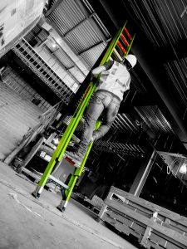
One of the most important steps when setting up an extension ladder is making sure the ladder is at the correct angle. When an extension ladder is being used, it should be at a 75.5 degree angle. A couple of tools have been created to help the user find the correct angle.

The NIOSH App
NIOSH created an app with great ladder safety tips. The app includes information on how to do a thorough ladder inspection. It also has a way to check the ladder's angle. You open the app and set your phone on the ladder rung. The app then tells you if you need to have your ladder less or more steep.

Bubble Indicators
Some ladders, including the HyperLite, have bubble indicators that show the operator when the ladder is level. These indicators help the operator know if the ladder needs to be made more or less steep.

The 4-to-1 Rule
If you don't access to a ladder with bubble indicators or the NIOSH app, the next best thing is to think of the 4-to-1 rule for ladder safety. For every four feet of ladder height you are climbing, move the base of the ladder one foot from the wall.
These tips will help you climb safely when using an extension ladder so you can complete your job and not become a statistic.

Sample Social Media Posts

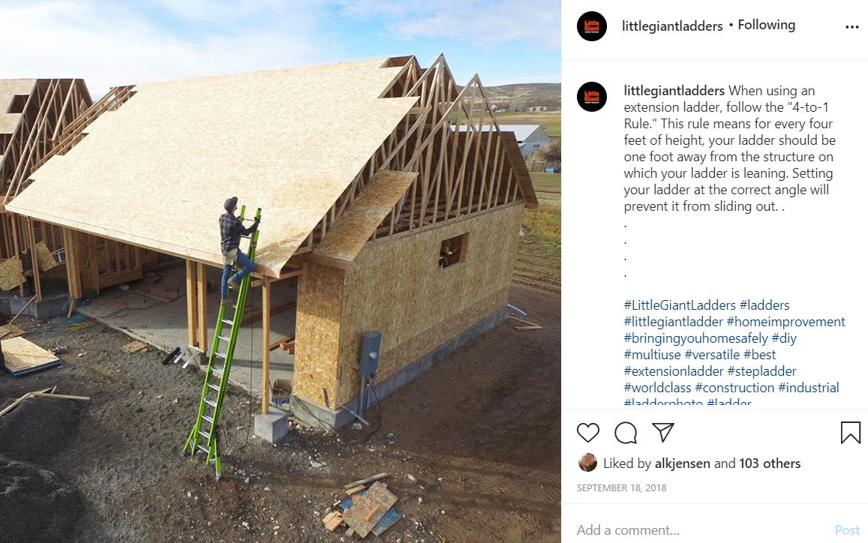

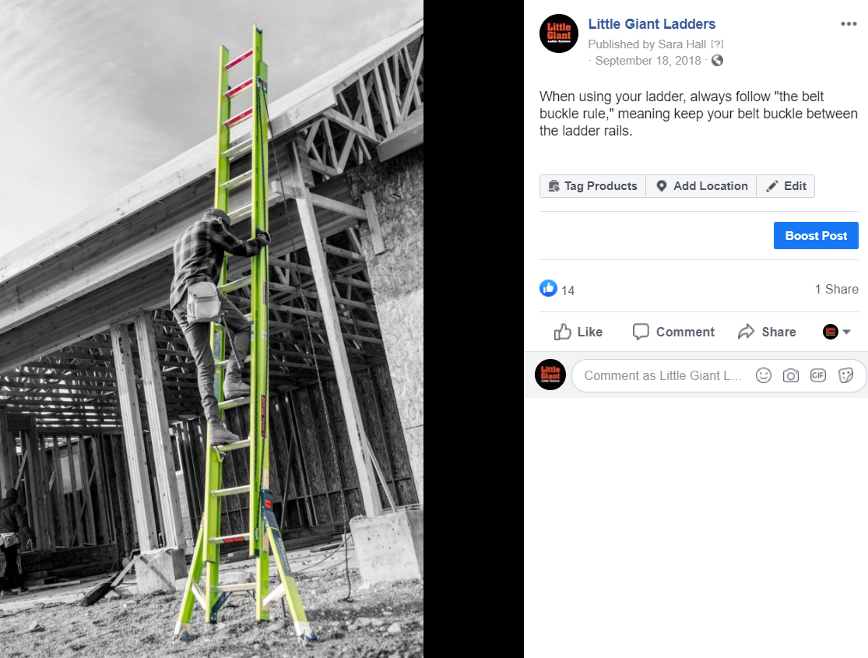

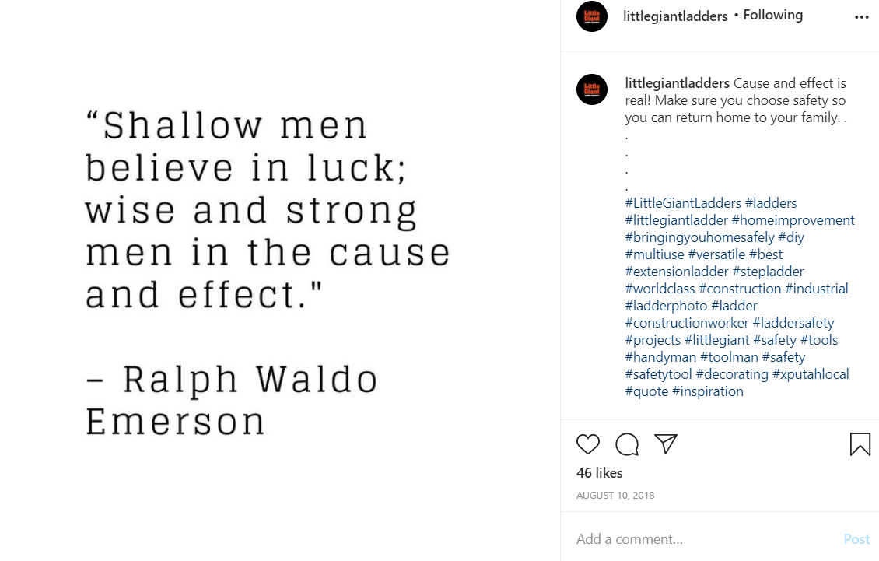

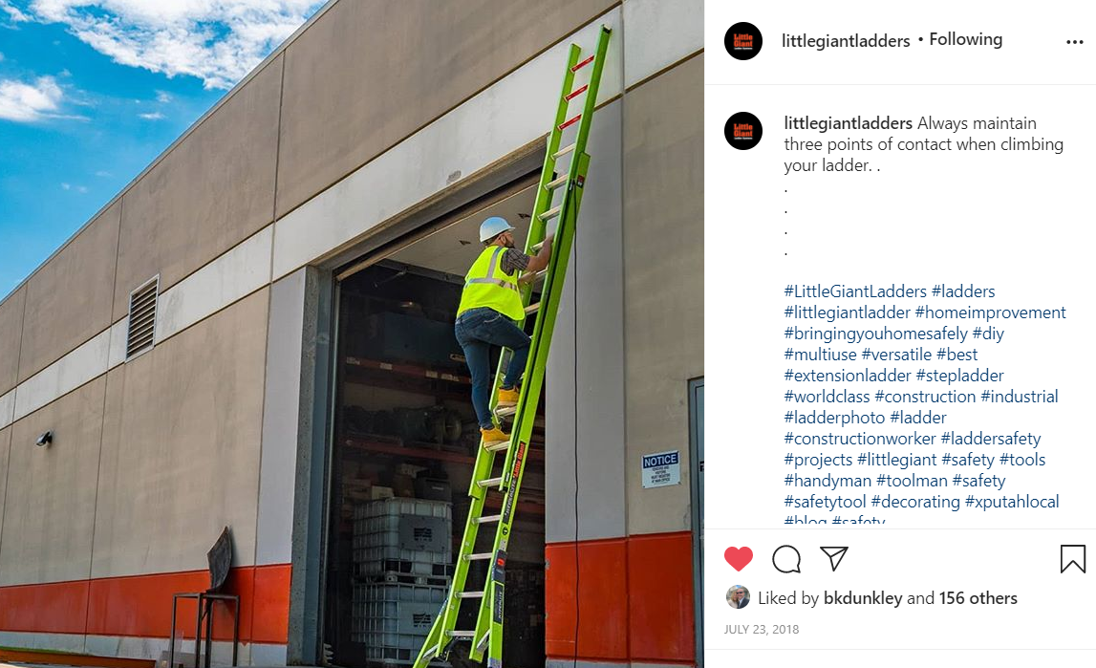

Ladder Safety Month Community Ladder Safety Training Invite
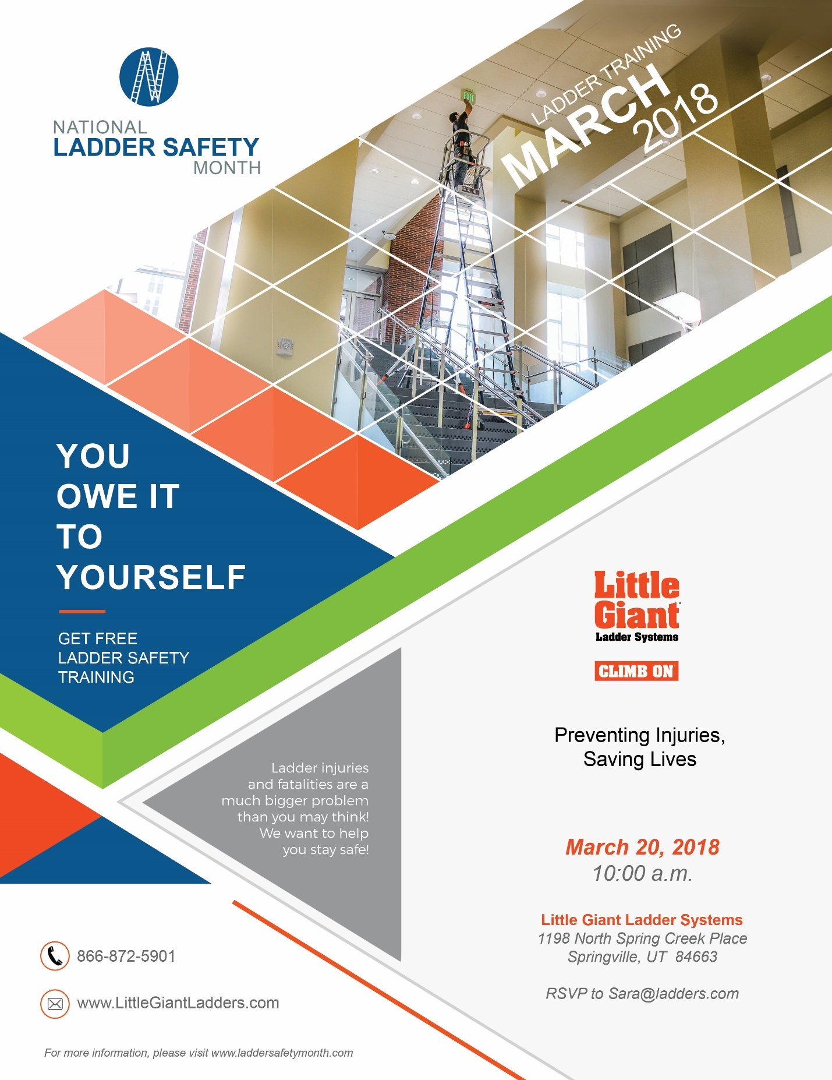

Sample Press Release Announcing an Award

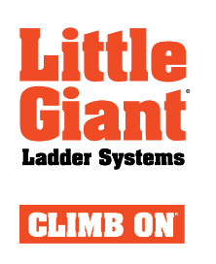

Little Giant HyperLite SumoStance Wins Award from Canadian Society of Safety Engineering

Springville, Utah, September 17, 2018 – The Canadian Society of Safety Engineering awarded Little Giant Ladder Systems with the Best Product of the Year for the HyperLite SumoStance after delegates at the CSSE Professional Development Conference & Exhibition voted for it.
“We are honored have this ladder be recognized by the CSSE,” said Ryan Moss, CEO. “The HyperLite SumoStance is one of the most innovative products in the market and we are excited it is receiving so much recognition. This ladder was engineered by some of the best. It was truly made to prevent injuries and saving lives, and it is already doing that by preventing both strains and sprains from lifting and carrying heavy ladders and catastrophic falls from overreaching.”

The Little Giant HyperLite SumoStance comes in patent-pending Hi-Viz green and is the lightest Type IA and IAA fiberglass extension ladder in the world with wide-stance levelers. The HyperLite SumoStance weights up to 40 percent less than ordinary fiberglass ladders, without sacrificing strength or stability. The wide-stance levelers increase side-tip stability, helping prevent the catastrophic injuries caused by using unstable extension ladders. This new category of extension ladders works on nearly any uneven surface while still weighing less than ordinary fiberglass extension ladders. The HyperLite SumoStance was also the winner of Occupational Health & Safety magazine’s 2017 New Product of the Year Award for Fall Protection/Fall Prevention.

Additional Resources:
• FAQs & Video: https://littlegiantladders.com/ladder/hyperlite-sumostance/
• Blog: www.laddersafetyhub.com
• Facebook: www.facebook.com/LittleGiantLadders
###
About Little Giant Ladder Systems:
Little Giant Ladder Systems, Inc. manufactures and distributes superior-quality climbing products worldwide. As the industry leader in ladder safety innovation, the company’s growing family of brands includes Little Giant Ladders®, Little Giant Xtreme™, Aerial Safety Cage™, Select Step™, Dark Horse™, HyperLite™ and HyperLite SumoStance®.
More
2

About the Canadian Society of Safety Engineering
CSSE was founded in 1949 by a small group of dedicated individuals drawn together in the common cause of accident prevention. It grew from a provincially-based organization to become Canada's largest national and most established professional organization for health and safety practitioners. Today, we have over 4,000 members across Canada, the United States, and around the world working together to enhance the health, safety and environmental profession.

For more information contact:
Sara Hall, Corporate Communications
801-489-3684
sara@ladders.com
Free Ladder Safety Training Copy Outline

Key public: safety professionals
•Demographics: Age 25 - 55. Working class. They work where ladders are used regularly.
•Psychographics: concerned with safety and wanting to help workers be safe.
Motivating Self-Interests: They want to help “their people” or their employees get home safely. They also want to decrease the number of on-the-job injuries
Proposed Speaker: Dave Francis
Key Learning Objectives:
- Recognize ways to reduce the three most common kinds of ladder-related accidents and injuries.
- Identify recent advancements in climbing equipment that will reduce risks on the job.
- Improve workplace safety training by utilizing free live and online resources.
- Demonstrate teaching techniques that will improve safety training among coworkers.
Key Messages
Little Giant is working to prevent injuries and save lives.
- Every day, 2000 people are injured in a ladder-related accident. Three hundred people are permanently injured. And every single day someone dies.
- Little Giant innovates solutions to common ladder-related issues and works to prevent injuries and save lives.
- Almost all ladder-related injuries can be prevented.
- Use the right ladder for the job.
- Choose the right size ladder.
- Follow the belt buckle rule every single time you climb.
- Take advantage of the latest options in ladder technology.

Proposed Locations: Various locations around the US, including Disney, Boeing and Exxon Mobile.
Necessary Materials: Ladders shipped from Little Giant Ladders, laptop and projector for PowerPoint presentation
Point of Contact: Dave Francis will coordinate with each company
Proposed Date: Bi-weekly during 2018.

Speaking Opportunity at Safety Conferences Application
Title of Presentation:
Fall Prevention vs. Fall Protection: A New Safety Category

Session Level:
Intermediate

Session Abstract (1000 character limit):
Including a fall prevention ladder safety training session at your conference would provide a valuable, informative, and popular topic for your attendees due to the nationwide problem, demand, and interest. Fall prevention is the new focus of safety leaders and professionals. Prevention through design, combined with new trainings, is helping organizations save time, money, and most importantly, lives. As the nation’s ladder safety expert, David Francis’ experience, reputation, and charismatic personality would be the ideal fit for your show.

Every day nearly 2,000 people are injured while using a ladder, and as many as 100 of them will suffer a long-term disability. Today, one person will die in a ladder-related accident. Four of OSHA’s top ten ‘serious’ violations in 2017 (#1, #3, #6, #9) were related to falls. Reducing the number of ladder-related injuries is becoming top priority for the nation’s foremost companies.

How the Content Will Be Presented:
Listeners will be wrapped in attention and will be drawn to this engaging presentation. Dave’s use of case studies, real-life examples and practical solutions involving cutting-edge strategies to prevent prevalent OSHA/safety compliance ladder-related issues will hold participants interest for the entire session. As a gifted presenter that involves the audience, Dave disseminates valuable information at a timely pace. In addition, his use of audio/visual teaching tools makes this a number one requested safety training with top companies in many industries around the nation.

4 Learning Objectives:
Upon completing this session, the participant should be able to:
- Recognize ways to reduce the three most common kinds of ladder-related accidents and injuries.
- Identify recent advancements in climbing equipment that will reduce risks on the job.
- Improve workplace safety training by utilizing free live and online resources.
- Demonstrate teaching techniques that will improve safety training among coworkers.

Nationwide Trainings:
Dave Francis is an industry expert and thought leader in ladder safety training. Within the last year alone, he has been invited to provide on-site ladder safety training to companies coast-to-coast in fields ranging from airlines to construction, cable communications to space travel, entertainment to oil refining, manufacturing to alarm systems. Companies requesting Dave’s training include:
- ADT Security Systems
- American Society of Safety Engineers
- Association of Building Contractors
- Boeing
- Chevron Phillips
- Comcast
- DIRECTV
- DISH
- Disney

Ladder Safety Month Examples

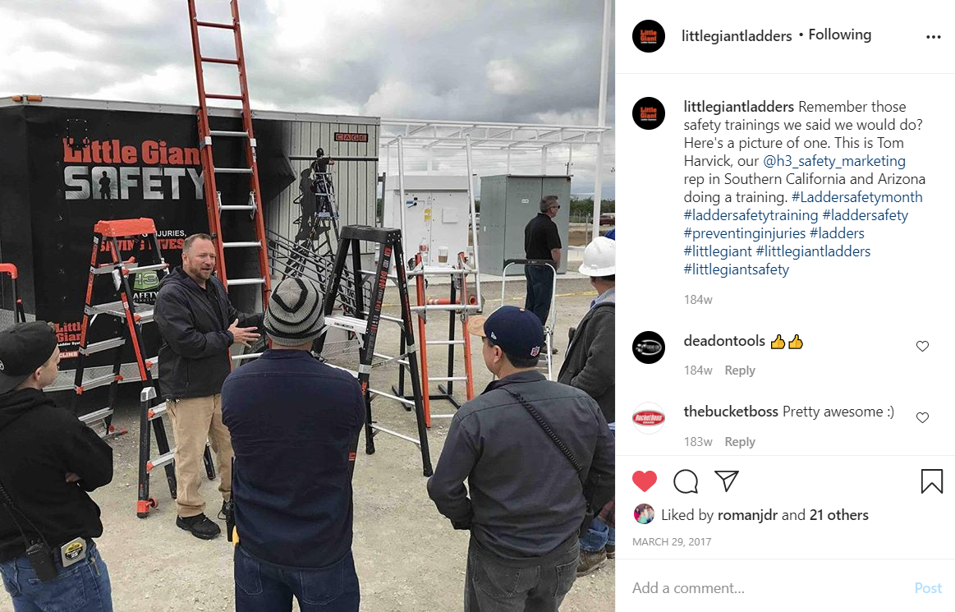



ALI Ladder Safety Training

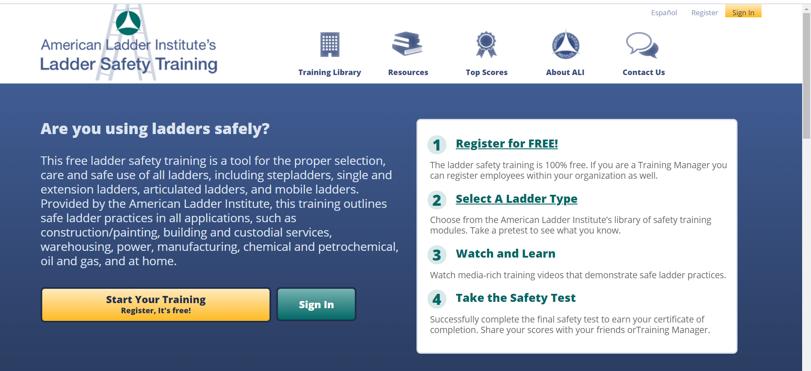

Company Ladder Safety Training/Copy Outline

Key public: Little Giant Employees
Demographics: Little Giant employees work primarily out of Springville, Utah. One hundred of these employees work in manufacturing, and 50 of them work in administration. They vary in age. Roughly half of the company’s employees speak Spanish.
Psychographics: Employees are loyal to Little Giant and want to keep Little Giant customers safe and happy. Many employees are familiar with the messaging of preventing injuries. They don’t always see the connection between ladder safety and their jobs.

Proposed Speaker: Dave Francis

Key Messages
Little Giant’s employees are ladder safety experts.
- Little Giant’s “why” is to prevent injuries and save lives.
- Every day, 2000 people are injured in a ladder-related accident. Three hundred people are permanently injured. And every single day someone dies.
- Little Giant is working to decrease these statistics.
- Little Giant innovates solutions to common ladder-related issues to prevent injuries and save lives.
- Almost all ladder-related injuries can be prevented through proper training and proper equipment.
- Every rung, every weld, every rivet is part of bringing people home safely.

Proposed Locations: Manufacturing Breakroom
Necessary Materials: Ladders for demo, laptop and projector for PowerPoint presentation
Point of Contact: Nikki Allen & Sara Hall for coordination efforts
Proposed Date: March 5, 2018.

Little Giant manufacturing Sample Graphics




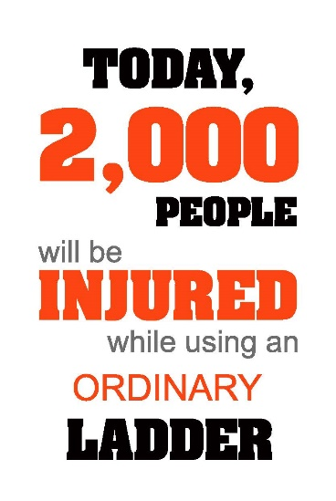
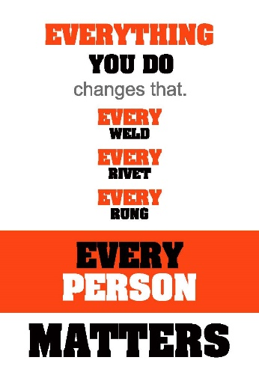

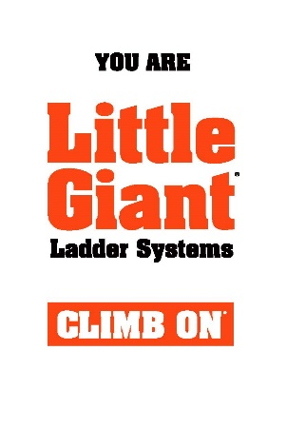

Employee newsletter Sample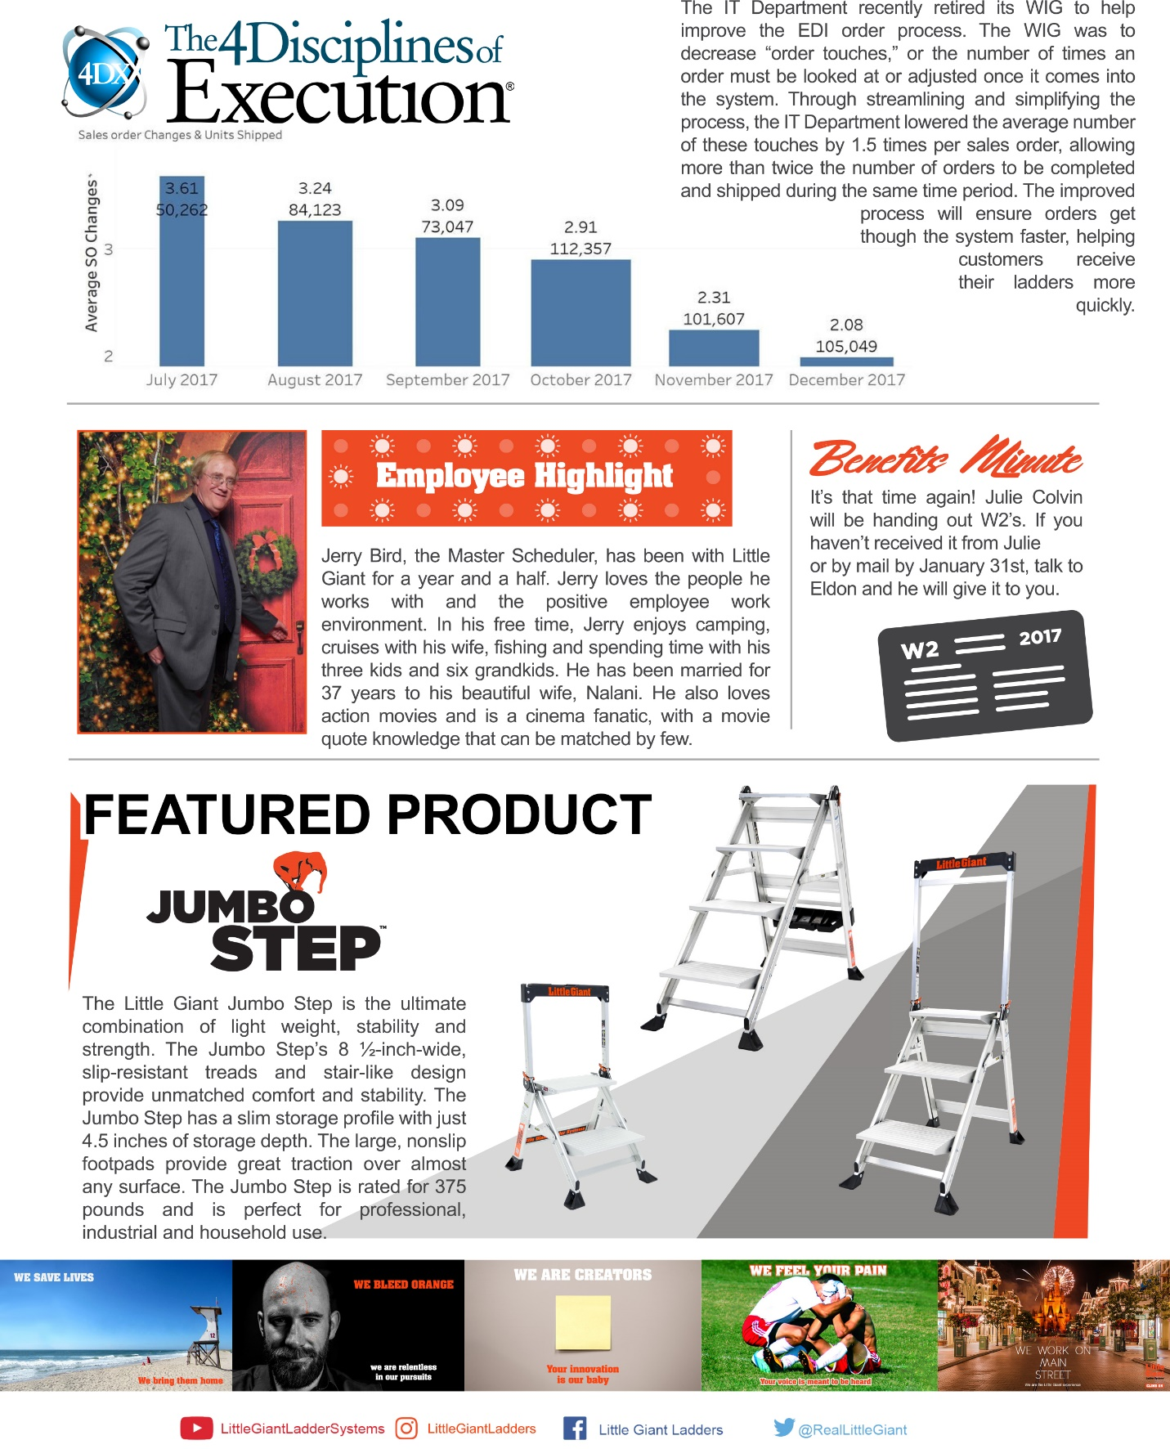

Team onboarding Copy Outline

Key public: New Little Giant Employees
The new employees vary in education and job responsibilities, age and ethnic background. They are new to the company culture and do not know about the company “why” or anything about ladder safety.

Proposed Teacher: Jaime Perry, HR Manager

Key Messages
Little Giant’s employees are ladder safety experts.
- Little Giant’s “why” is to prevent injuries and save lives.
- Every day, 2000 people are injured in a ladder-related accident. Three hundred people are permanently injured. And every single day someone dies.
- Little Giant is working to decrease these statistics.
- Little Giant innovates solutions to common ladder-related issues to prevent injuries and save lives.
- Almost all ladder-related injuries can be prevented through proper training and proper equipment.
- Every rung, every weld, every rivet is part of bringing people home safely.

Proposed Locations: Conference Room, as part of the plant tour
Point of Contact: Jaime Perry, HR Manager
Proposed Date: New Employee First Day (varies)

Evaluation

Objective 1:
Increase awareness of the national ladder safety problem from 60% recognition to 70% recognition between January 1, 2018 and December 31, 2018.

Little Giant fell a little short of this objective by reaching 68% recognition of the ladder safety problem. The most effective tactics were the articles in the trade publications. In 2018, 12 articles were placed in nine publications. Coordinating with the ALI for Ladder Safety Month was also effective since Little Giant was able to participate in a national conversation about Ladder Safety.

Objective 2:
Increase choice of Little Giant as the most safe, innovative company by safety officers from 40% to 60% between January 1, 2018 and December 31, 2018.

Little Giant met this objective with 60% of those surveyed choosing Little Giant as the most save, innovative company. The most effective tactics for this objective were the free training and the conference speaking opportunities since they both brought Little Giant to audiences that would have been hard to reach otherwise. The National Safety Director provided training to 50 different organizations, including BP Oil, Boeing and the Walt Disney Company. He also spoke at four safety conferences over the course of the year. Additionally, Little Giant did receive two innovation awards in 2018.

Objective 1:
Build awareness of the “Little Giant Why” from 50% of employees to 90% percent of employees between January 1, 2018 and December 31, 2018.

Little Giant surpassed this objective by having 95% of all employees understand the “Little Giant Why.” The manufacturing banners helped remind manufacturing employees, and the company training and improved on-boarding experience showed the importance of preventing injuries and saving lives for both new and old employees. The newsletter was also helpful in providing regular reminders to employees.

Overall, this campaign was considered a success, but lessons were still learned. One thing Little Giant learned with this campaign is that it is that safety officers have a good relationship with the brand, but in focusing so much on safety officers, they missed an important key public important to brand awareness. In addition to safety officers, Little Giant should have had contractors as a public because their relationships with various brands are stronger.

